**Classes**

Reading - Music Appreciation  
Bible Study - Current Events

**Computers available onsite**

# Line dancing classes with Juanita Every 2nd & 4th Tuesday of the month

See Seniors Getting Down 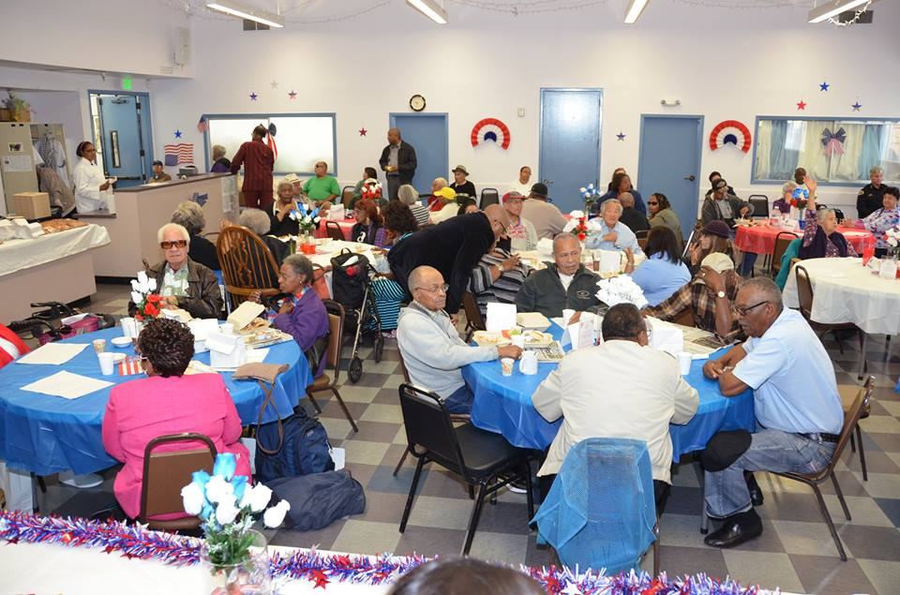

Come early and Join us for lunch @ 12

**Van to the Senior Center**

**Must register on-site first; donation requested**

**Please call  
650.329.5900**

# **Meal Services**

# Meal services offered on-site M - F

**50 cent continental breakfast 9 am   
$3 lunch 11:30-12:30   
$6 under 60**

Join us on Thursdays for country breakfasts and box lunches

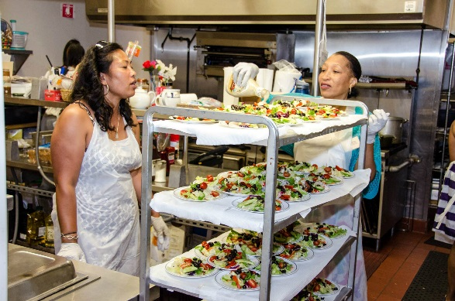

**Please call  
650.688.1824**

**We welcome any volunteers or donations to the meal services program THANK YOU**

**Community Services**

We're happy to provide information on

**Housing, employment, household help, recreation, financial assistance, health services and in-home help**

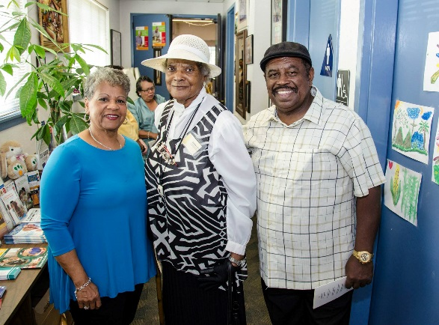

**Health education and screenings are also provided at the East Palo Alto Senior Center**

**oe in and see us!**